**COMPUTER SCIENCE & ENGINEERING**

Face Recognition System

SUBMITTED TO-

Mr. SAGAR PANDE

From:-

MD SAMIR AKHTAR (11903339 )

**ABSTRACT**

A face recognition system is one of the biometric information processes, its applicability is easier and working range is larger than others, i.e.; fingerprint, iris scanning, signature, etc. The system uses a combination of techniques in two topics; face detection and recognition. The face detection is performed on live acquired images without any application field in mind. Processes utilized in the system are white balance correction, skin like region segmentation, facial feature extraction and face image extraction on a face candidate. Then a face classification method that uses Feed Forward Neural Network is integrated in the system. The system is tested with a database generated in the laboratory with peoples. The tested system has acceptable performance to recognize faces within intended limits. System is also capable of detecting and recognizing multiple faces in live acquired images.

**ACKNOWLEDGEMENTS**

We express our deep sense of gratitude to our beloved professor Mr. Sagar Pande, Department of CSE, Lovely Professional University for permitting us to carry out this project for the valuable guidance and suggestions, keen interest and through encouragement extended throughout period of project work.

This project is completed by me I have not taken any help from others.

With gratitude,

MD SAMIR AKHTAR

**INDEX**

**Abstract**

**Acknowledgements**

**CONTENTS**

1. **Introduction**
2. **Review of Literature**
3. **Project Contribution**

* Material and Methods
* Discussion

1. **References**

* Appendices

**INTRODUCTION**

In recent years, the study of image analysis and its use in facial recognition applications has gained significant attention from the worldwide research community. Facial recognition is a popular research area in pattern recognition and computer vision due to its wide range of commercial and law enforcement applications, including passports, credit cards, drivers’ licenses, biometric authentication, video surveillance, and information security (Zhao et al, 2003; Phillips et al, 1997). These applications demands user-friendly automatic systems that can secure our assets and protect our privacy without losing our identity. Although researchers in various fields like psychology, neural sciences and engineering, image processing and computer vision have investigated a number of issues related to personal identification and machines

**Background**

In this section some of the technologies frequently used for facial recognition are briefly reviewed. In general, facial recognition systems proceed by capturing the face in an image, with the effect of estimating and normalizing for translation, scale and in-plane rotation. Given a normalized image, the features, either global or local, are extracted and compressed in a compact face representation which can then be stored in an image database and compared with face representations/search images derived at later times. The research on face recognition generally falls into two main categories (Chellappa et al., 1995) i.e: 1. Feature-based approach and 2. Holistic or global approach Feature-based approaches: Facial recognition based on feature-based approaches relies on the detection and characterization of individual facial features and their geometrical relationships. Such features generally include the eyes, nose, and mouth. The detection of faces and their features prior to performing verification or recognition makes these approaches robust to positional variations of the faces in the input image. Holistic or global approaches: Facial recognition based on holistic approaches, on the other hand, involves encoding the entire facial image and treating the resulting facial “code” as a point in a high dimensional space. Here, it is assumed that all faces are constrained to particular positions, orientations, and scales.

**Principles and Methodology of Image Recognition System**

A pictorial representation of the automatic image recognition system, where the application is the automatic opening or closing of the door depending on the person who is reaching the door. If a known person reaches the door, it will automatically open; otherwise it will close the door. The design is based on recognition of biometric facial properties. Such automatic an image recognition system provides better assistance for physically challenged people. The said systems can be used in ATM banking system.

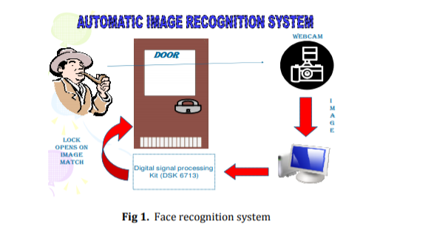

**OBJECTIVES:-**

To developing a unlocking system based on face recognition.

To acquire image from the USB-camera using image acquisition.

To implement face detection using skin color detection using face detection.

To design programming pn PCA algorithm face recognition.

To design serial communication to control the relay in the magnetic lock .

**CONCLUSIONS**

Face recognition system is a popular study task in the field of image processing and computer vision, owing to its potentially enormous application as well as its theoretical value. This system is widely deployed in many real-world applications such as security, surveillance, homeland security, access control, image search, human-machine, and entertainment. However, these applications pose different challenges such as lighting conditions and facial expressions. This paper highlights the recent research on the 2D or 3D face recognition system, focusing mainly on approaches based on local, holistic (subspace), and hybrid features. A comparative study between these approaches in terms of processing time, complexity, discrimination, and robustness was carried out. We can conclude that local feature techniques are the best choice concerning discrimination, rotation, translation, complexity, and accuracy

References

Wikipedia and Research paper on face recognition